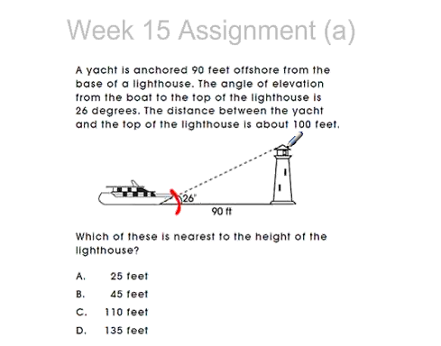

The correct answer is B

Tan = Opposite / Adjacent

Tan 26 = x/90

Tan 26 \* 90 = 43.9

X = 43.9 (45 Feet is closest)